**IFT 458/598: Middleware Prog & Database Security**

Anurag Shahare

Module 3 Assignment: Data Access

Dinesh Sthapit

October 1, 2022

Git: [https://github.com/AnuragShahare/M3A2new/](https://github.com/AnuragShahare/M3A2/)

**Step 1**

**Step 2:**

**Step 3**

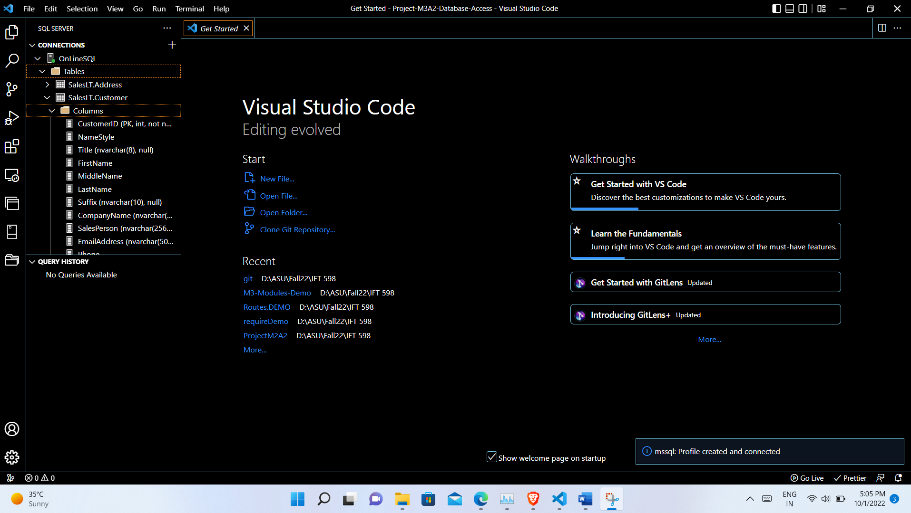

**Step 4**

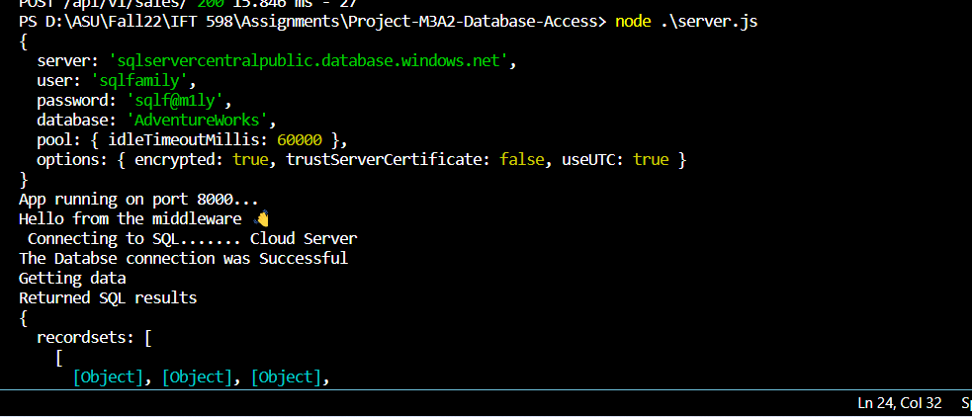

**Step 5:**

**Step 6:**

**Additional requirements:**

**Created Correct Individual SQL SELECT Statement to Query Data in four Tables**

**Show the SQL Statements that you used to create your Customer list.**

**Created Correct SQL statements to JOIN Data in more than one table**

**Show an example of joining two tables using COMPLETE SQL STATEMENTS with related data.**

